**Frank-Wolfe Algorithm Demonstration**

1. 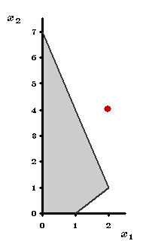**Introduction**

To illustrate the Frank-Wolfe algorithm, consider the demonstration example for the simplex method with a new objective function:

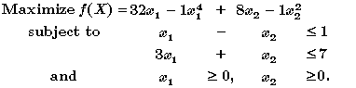

The feasible region is shown to the right. Without these constraints the maximum of http://ssdi.di.fct.unl.pt/mq/Docs/MaterialApoio/OR%20Tutor/np/algebra/fx.gif  is easily found (by setting the partial derivatives equal to zero) to be http://ssdi.di.fct.unl.pt/mq/Docs/MaterialApoio/OR%20Tutor/np/algebra/X=2,4.gif. But what is the constrained maximum? Let us use as the initial trial solution http://ssdi.di.fct.unl.pt/mq/Docs/MaterialApoio/OR%20Tutor/np/algebra/X=0,0_1.gif  for the Frank-Wolfe algorithm.

1. **Objective Approximation**

**Initial trial solution:**

http://ssdi.di.fct.unl.pt/mq/Docs/MaterialApoio/OR%20Tutor/np/algebra/X=0,0.gif

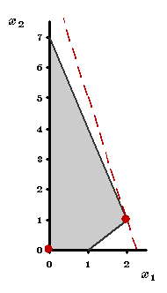http://ssdi.di.fct.unl.pt/mq/Docs/MaterialApoio/OR%20Tutor/np/fw/obj.gif

We begin the first iteration by developing a "linear approximation" for http://ssdi.di.fct.unl.pt/mq/Docs/MaterialApoio/OR%20Tutor/np/algebra/fx.gif near this trial solution. This is done by evaluating the partial derivatives at (0, 0):

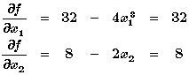

So this approximation is  http://ssdi.di.fct.unl.pt/mq/Docs/MaterialApoio/OR%20Tutor/np/fw/approx1.gif. Maximizing  http://ssdi.di.fct.unl.pt/mq/Docs/MaterialApoio/OR%20Tutor/np/algebra/gx.gif subject to the original constraints yields the solution   
 http://ssdi.di.fct.unl.pt/mq/Docs/MaterialApoio/OR%20Tutor/np/fw/X=2,1.gif  with http://ssdi.di.fct.unl.pt/mq/Docs/MaterialApoio/OR%20Tutor/np/fw/g2,1=72.gif. However since (2, 1) is not near (0, 0) the approximation may not be a good one at (2, 1). [Note that http://ssdi.di.fct.unl.pt/mq/Docs/MaterialApoio/OR%20Tutor/np/fw/f2,1=55.gif is well under http://ssdi.di.fct.unl.pt/mq/Docs/MaterialApoio/OR%20Tutor/np/fw/g2,1=72.gif.] Rather than just accepting (2, 1) as the next trial solution, let us check the line segment between (0, 0) and (2, 1) and choose the http://ssdi.di.fct.unl.pt/mq/Docs/MaterialApoio/OR%20Tutor/np/algebra/X.gif with the largest http://ssdi.di.fct.unl.pt/mq/Docs/MaterialApoio/OR%20Tutor/np/algebra/fx.gif.

1. 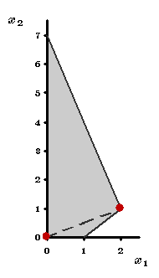**Changing Solution**

http://ssdi.di.fct.unl.pt/mq/Docs/MaterialApoio/OR%20Tutor/np/fw/obj.gif

The equation for the line segment between (0, 0) and (2, 1) is

http://ssdi.di.fct.unl.pt/mq/Docs/MaterialApoio/OR%20Tutor/np/fw/line1.gif

Since http://ssdi.di.fct.unl.pt/mq/Docs/MaterialApoio/OR%20Tutor/np/fw/x1=2t.gif and http://ssdi.di.fct.unl.pt/mq/Docs/MaterialApoio/OR%20Tutor/np/fw/x2=t.gif, the values of http://ssdi.di.fct.unl.pt/mq/Docs/MaterialApoio/OR%20Tutor/np/algebra/fx.gif on the line are

http://ssdi.di.fct.unl.pt/mq/Docs/MaterialApoio/OR%20Tutor/np/fw/defh.gif

The point http://ssdi.di.fct.unl.pt/mq/Docs/MaterialApoio/OR%20Tutor/np/fw/X=2t,t.gif on this line segment having the largest http://ssdi.di.fct.unl.pt/mq/Docs/MaterialApoio/OR%20Tutor/np/algebra/fx.gif is found by maximizing http://ssdi.di.fct.unl.pt/mq/Docs/MaterialApoio/OR%20Tutor/np/fw/ft.gif over http://ssdi.di.fct.unl.pt/mq/Docs/MaterialApoio/OR%20Tutor/np/fw/t_limit.gif by the one-dimensional search procedure, which yields http://ssdi.di.fct.unl.pt/mq/Docs/MaterialApoio/OR%20Tutor/np/fw/topt.gif. Therefore the new trial solution is http://ssdi.di.fct.unl.pt/mq/Docs/MaterialApoio/OR%20Tutor/np/fw/Xopt.gif.

1. **Next Iteration**

**Second trial solution:**

http://ssdi.di.fct.unl.pt/mq/Docs/MaterialApoio/OR%20Tutor/np/fw/X=2,1.gif

http://ssdi.di.fct.unl.pt/mq/Docs/MaterialApoio/OR%20Tutor/np/fw/obj.gif

We begin the second iteration by evaluating the partial derivatives of http://ssdi.di.fct.unl.pt/mq/Docs/MaterialApoio/OR%20Tutor/np/algebra/fx.gif at (2, 1):

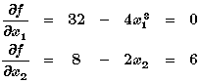

So the approximated objective function is http://ssdi.di.fct.unl.pt/mq/Docs/MaterialApoio/OR%20Tutor/np/fw/approx2.gif. Maximizing http://ssdi.di.fct.unl.pt/mq/Docs/MaterialApoio/OR%20Tutor/np/fw/approx2.gif subject to the original constraints yields the solution http://ssdi.di.fct.unl.pt/mq/Docs/MaterialApoio/OR%20Tutor/np/fw/X=0,7.gif with http://ssdi.di.fct.unl.pt/mq/Docs/MaterialApoio/OR%20Tutor/np/fw/g0,7=42.gif. [Note that http://ssdi.di.fct.unl.pt/mq/Docs/MaterialApoio/OR%20Tutor/np/fw/f0,7=7.gif.] The line between (2, 1) and (0, 7) is

http://ssdi.di.fct.unl.pt/mq/Docs/MaterialApoio/OR%20Tutor/np/fw/line2.gif

http://ssdi.di.fct.unl.pt/mq/Docs/MaterialApoio/OR%20Tutor/np/fw/defh_2.gif

which is maximized at http://ssdi.di.fct.unl.pt/mq/Docs/MaterialApoio/OR%20Tutor/np/fw/topt_2.gif. The resulting new trial solution is

http://ssdi.di.fct.unl.pt/mq/Docs/MaterialApoio/OR%20Tutor/np/fw/Xopt_2.gif

1. **Final Iteration**

**Third trial solution:**

http://ssdi.di.fct.unl.pt/mq/Docs/MaterialApoio/OR%20Tutor/np/fw/X=dec.gif

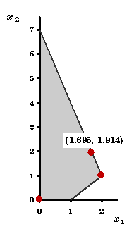http://ssdi.di.fct.unl.pt/mq/Docs/MaterialApoio/OR%20Tutor/np/fw/obj.gif

Evaluating the partial derivatives at (1.695, 1.914):

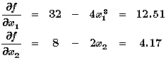

so the approximating objective function is http://ssdi.di.fct.unl.pt/mq/Docs/MaterialApoio/OR%20Tutor/np/fw/approx3.gif. Maximizing http://ssdi.di.fct.unl.pt/mq/Docs/MaterialApoio/OR%20Tutor/np/fw/approx3.gif, or equivalently (after dividing by 4.17) http://ssdi.di.fct.unl.pt/mq/Docs/MaterialApoio/OR%20Tutor/np/fw/approx3_1.gif, results in **every** solution on the line between (2, 1) and (0, 7) being optimal for this linear programming problem. Regardless of which solution is used as the other endpoint of the line from (1.695, 1.914), we already know from the preceding iteration that http://ssdi.di.fct.unl.pt/mq/Docs/MaterialApoio/OR%20Tutor/np/algebra/fx.gif is maximized along this line at (1.695, 1.914). Since the trial solution did not move, this verifies that the optimal solution for our convex programming problem is

http://ssdi.di.fct.unl.pt/mq/Docs/MaterialApoio/OR%20Tutor/np/fw/X=dec.gif