|  |  |
| --- | --- |
| Delft University of TechnologyDepartment of Aerospace Engineering | |
| Course: Physics I (AE1240) | Course year: 1 |
| Date: 10-04-2015 | Time: 09:00-12:00 |
| Student name and initials (capital letters):…………………………………… | |
| Student number: .…………………………………… | |
| Lectures you followed (cross as appropriate) □ Kotsonis □ Colonna | |
| Instructions  Write your answers using the blank space on the page where the problem is given.  Or use the back of the page, if necessary.  Deliver ONLY the present booklet at the end of the exam. (do not include scrap paper or any other sheet)  PLEASE TAKE NOTE OF THE PARAMETER VALUES LISTED AT THE BOTTOM OF THIS PAGE  YOU CAN USE THE OFFICIAL EQUATIONS SHEET IF DISTRIBUTED.  THE USE OF OTHER INFORMATION CARRIERS IS STRICTLY FORBIDDEN. | |

## Problem 1: (15 points)

## True or false exercise (mark with X the appropriate box after the statement)

|  |  |  |
| --- | --- | --- |
| **Statement** | **True** | **False** |
| 1 – Entropy has the same dimensional units as energy |  | x |
| 2 – A modern petrol engine can be more efficient than a Carnot heat engine |  | x |
| 3 – The value of the internal energy of an ideal gas is always larger than the value of the enthalpy at a given temperature |  | x |
| 4 – By definition *cp* is always smaller than *cv* |  | x |
| 5 – Temperature is an intensive property | x |  |
| 6 – Mixing adiabatically hot and cold gases to a new equilibrium state will increase their entropy | x |  |
| 7 – The production of entropy in the universe is zero |  | x |
| 8 – Temperature is proportional to volume in an isobaric process of an ideal gas | x |  |
| 9 – In a polytropic process the pressure can change independently of the volume |  | x |
| 10 – Removing energy as heat from a closed system reduces its entropy | x |  |
| 11 – An explosion of a gas in a box determines a sudden entropy production in the box | x |  |
| 12 – A system formed by a simple compressible substance enclosed in a constant volume cannot transfer energy as work | x |  |
| 13 – Colour is a thermodynamic property |  | x |
| 14 – Under adiabatic conditions work becomes a state variable |  | x |

APPENDIX

Universal gas constant: *R* = 8.314 J/mol ⋅ K

Gas constant for air: *Rair* = 287 J/kg ⋅ K

Specific heat at constant pressure for air: *cp* = 1008 J/kg ⋅ K

Ratio of specific heats for air: *k* = 1.4**Problem 2 (10 points)**

A person weighing 85 kg gets into an elevator at the lobby level of a hotel together with a 30-kg suitcase, and gets out at the 10th floor 35 m above. (a) Determine the amount of energy as work transferred by the motor to the elevator that is now stored in the suitcase. (b) if the efficiency of the elevator system is 90 % determine the total energy that got transferred for the above trip.

**Answer:**

**2-18** A person with his suitcase goes up to the 10th floor in an elevator. The part of the energy of the elevator stored in the suitcase is to be determined.

***Assumptions* 1** The vibrational effects in the elevator are negligible.

***Analysis***

(a) The energy stored in the suitcase is stored in the form of potential energy, which is *mgz*.Therefore,



Therefore, the suitcase on 10th floor has 10.3 kJ more energy compared to an identical suitcase on the lobby level.

(b) The total energy for the trip is again the potential energy but with the sum of the person’s and suitcases’s mass. Taking into account efficiency of 90 % the total consumed energy is :

Ein = Eout/n = mgΔz/n= (30+85 kg)(9.81 m/s2)(35 m)/0.9 = **43.9 kJ**

**Problem 3 (15 points)**

A mass of 5 kg of saturated water vapor at 300 kPa is heated in a cylinder-piston system at constant pressure until the temperature reaches 200°C. Calculate the work done by the steam on the piston during this process.

**Answer:**

**4-11** Saturated water vapor in a cylinder is heated at constant pressure until its temperature rises to a specified value. The expansion work done by the gaseous steam on the piston during this process is to be determined.

***Assumptions*** The process is quasi-equilibrium.

***Properties*** Noting that the pressure remains constant during this process, the specific volumes at the initial and the final states are (Table A-4 through A-6)

*P*

(kPa)

*V*

300

1

2



***Analysis*** The expansion work is determined from its definition to be



#### Discussion ***The positive sign indicates that work is done by the system (work output).***

**Problem 4 (15 points)**

Steam flows steadily through an adiabatic turbine. The inlet conditions of the steam are 10 MPa, 450°C, and 80 m/s, and the exit conditions are 10 kPa, 92 percent quality, and 50 m/s. The mass flow rate of the steam is 12 kg/s. Determine (*a*) the change in kinetic energy of the steam, (*b*) the power output, and (*c*) the turbine inlet area.

STEAM

*m* = 12 kg/s

·

*P*1 = 10 MPa

*T*1 = 450°C

*V*1 = 80 m/s

*P*2 = 10 kPa

*x*2 = 0.92

*V*2 = 50 m/s

*W*

·

**Answer**

**5-52** Steam expands in a turbine and the system is at steady state. The change in kinetic energy, the power output, and the turbine inlet area are to be determined.

***Assumptions*** **1** This is a steady-flow process since thus there is no change of any property with time at any fixed location within the system boundary. **2** Potential energy changes are negligible. **3** The device is adiabatic and thus energy transfer as heat across the system boundary is negligible.

***Properties*** From the steam tables (Tables A-4 through 6)

STEAM

*m* = 12 kg/s

·

*P*1 = 10 MPa

*T*1 = 450°C

*V*1 = 80 m/s

*P*2 = 10 kPa

*x*2 = 0.92

*V*2 = 50 m/s

*W*

·



and



***Analysis*** (a) The change in kinetic energy is determined from



(*b*) There is only one inlet and one exit, and thus . We take the turbine as the system, which is a control volume since mass crosses the boundary. The energy balance for this steady-flow system can be expressed in the rate form as



Then the power output of the turbine is determined by substitution to be



(*c*) The inlet area of the turbine is determined from the mass flow rate relation,



**Problem 5 (20 points)**

An ideal Otto cycle has a volumetric compression ratio of 7. At the beginning of the compression process, *P*1 = 90 kPa, *T*1 = 27°C, and *V*1 = 0.004 m3. The maximum cycle temperature is 1127°C. For each repetition of the cycle, calculate (a) the energy transfer as heat from the system to the environment (“heat rejection”), (b) the net energy transfer as work from the system (“work production” or work output). Also calculate (c) the thermal efficiency and (d) the mean effective pressure (MEP) for this cycle. Use constant specific heats at room temperature.

***Properties*** The properties of air at room temperature are: *R* = 0.287 kJ/kg.K,  *cp* = 1.005 kJ/kg·K, *cv* = 0.718 kJ/kg·K, and *k* = 1.4

**Answer**

**9-47** An ideal Otto cycle is considered. The heat rejection, the net work production, the thermal efficiency, and the mean effective pressure are to be determined.

***Assumptions*** **1** The air-standard assumptions are applicable. **2** Kinetic and potential energy changes are negligible. **3** Air is an ideal gas with constant specific heats.

***Properties*** The properties of air at room temperature are *R* = 0.287 kJ/kg.K,  *cp* = 1.005 kJ/kg·K, *cv* = 0.718 kJ/kg·K, and *k* = 1.4 (Table A-2a).

***Analysis*** The mass of air contained in this system can be determined as

*v*

*v*

*P*

4

1

3

2

*q*out

*q*in



The two unknown temperatures are



Application of the first law to four cycle processes gives



The net work is



The thermal efficiency is then



The minimum volume of the cycle occurs at the end of the compression



The engine’s mean effective pressure is then



**Problem 6 (25 points)**

An ideal air-standard Brayton cycle with regeneration produces 150 kW. The pressure ratio is 8. The minimum temperature in the cycle is 293 K while the maximum temperature is 1073 K. The difference between the hot and cold air stream temperatures is 10°C at the end of the regenerator where the cold stream leaves the regenerator. Determine (a) the rate of energy transfer as heat to the system (“heat addition”) and (b) the rate of energy transfer as heat to the environment (“heat rejection”).

***Properties*** The properties of air at room temperature are *cp* = 1.005 kJ/kg.K and *k* = 1.4

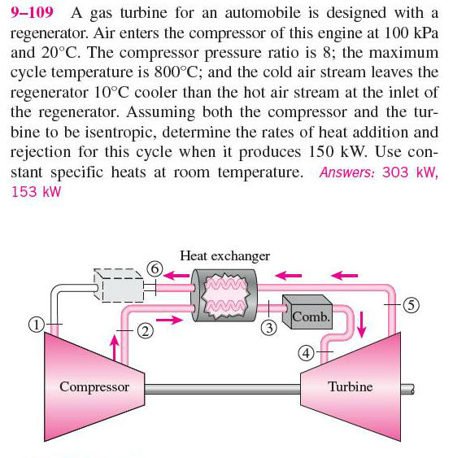

*s*

*T*

1

2

5

4

*q*in

1073 K

293 K

3

6

*q*out

**Answer**

**9-111** A Brayton cycle with regeneration produces 150 kW power. The rates of energy transfer as heat to and from the system (heat addition and rejection) are to be determined.

***Assumptions* 1** The air standard assumptions are applicable. **2** Air is an ideal gas with constant specific heats at room temperature. **3** Kinetic and potential energy changes are negligible.

***Properties*** The properties of air at room temperature are *cp* = 1.005 kJ/kg.K and *k* = 1.4 (Table A-2a).

***Analysis*** According to the isentropic process expressions for an ideal gas,



*s*

*T*

1

2

5

4

*q*in

1073 K

293 K

3

6

*q*out



If the first law is applied to the heat exchanger, the result is



while the regenerator temperature specification gives



The simultaneous solution of these two results gives



Application of the first law to the turbine and compressor gives



Then,



Applying the first law to the heating process gives



Similarly, for the air cooling process we have that

