Question 1

State whether the following statements are True or False.
You must justify your answer with a short explanation.
a) The International Terrestrial Reference Frame (ITRF2000) was created using a network of ground stations with known coordinates, which serve as realization of the reference system.
True, see previous exam

b) The Earth’s gravity field is often represented in mathematical terms as an infinite series of spherical surface harmonics.
True, Lecture 5 (of 2008), slide 13

c) The Earth’s geomagnetic field reverses its polarity at regular intervals.
True, in case the regulat intervals of time are meant. In case intervals as in distance, false.

d) The phase velocity of an electromagnetic wave can be higher than the speed of light in vacuum.
False, see Lecture 11, follows from Maxwell’s equations

e) Radar instruments are passive microwave systems.
True, see Lecture 16

Question 2 (3/3/3/3pt) Ch 2.6 Rees

a) What is a blackbody?
Perfect emitter of thermal radiation

b) Does it exist? If yes, describe it. If no, explain why not.
black body is an object that absorbs all light that falls on it. No electromagnetic radiation passes through it and none is reflected. Because no light is reflected or transmitted, the object appears black when it is cold. Such thing cannot exist in nature

c) What is the relation between a blackbody and the brightness temperature of an object?
Brightness temperature is the temperature of equivalent black body that would give the same radiance at the wavelength under consideration.

d) Make a sketch of the spectral radiance of a blackbody for different wavelengths and different temperatures. Indicate Wien’s law in the sketch

Wines law : λ_{max} = A/T
A = 2.898*10⁻³ Km
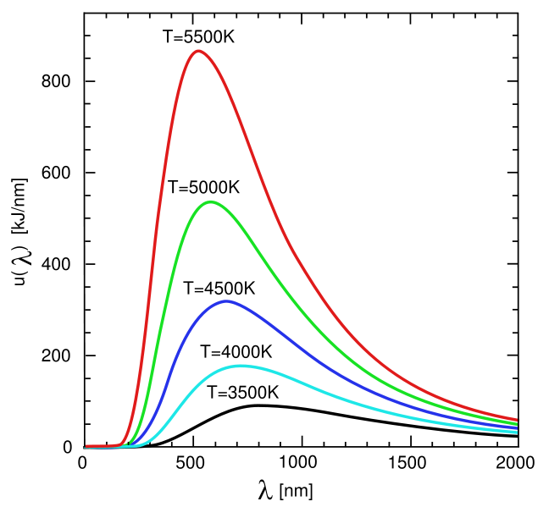
Question 3 (4/4/4pt) p293 Rees

Principal Component Analysis is a so-called band transformation frequently used for imaging remote sensing data.
a) State two of the main goals of principal component analysis.
In case of imagery having more than three bands, it will often occur that the first three principal components will contain a large percentage of total image variance. Thus, the effective dimensionality of the image data has been reduced by the transformation. Also one or more of the principal components will correlate with some physically meaningful variable, e.g. vegetated areas or water/land areas.

b) Explain the main principle of PCA in brief.
Imagine you have two-dimensional d1-d2 space as in question c. It is clear that there is a significant correlation between the two bands. However, by making suitable linear combinationsd1’ and d2’ from d1 and d2, this correlation can be removed. The actual transformation is just a rotation in the two-dimensional pizel value space. The angle of the rotation is determined by the correlation between the values of d1 and d2.

c) In Fig. 1, two datasets are shown. Each dataset consists of two variables, d1 and d2. For which of the two datasets will PCA be most successful? You must explain your answer.

I am not sure but I would say left one, since it is not so spread out, so the correlation is bigger and the strength and direction of a linear relationship between two data sets is better indicated. But also might be exactly other way round.

Question 4 (2/2/2/2/2pt) p.9

An electromagnetic wave is propagating along the x-axis.
The equation of the wave is
Ey = 0.009 · cos π (87t − 16x + 1)
Ez = 0.009 · cos π (87t − 16x − 1)

a) What is the amplitude of the wave?
0.009

b) What is the frequency of the wave?
(Angular frequency) = 87

c) What is the wavenumber of the wave?
16

d) What is the polarization type of the wave? Explain your answer.
Since φ_{y} - φ_{z} = -1 +1 = 0 → plane polarized

e) What is the wave velocity (phase velocity) of the wave?
Formula 3.26 → 87/16 = 5.4375

Question 5 (3/3/3/3pt) Ch. 6.2.4 Rees

Consider a diffraction grating in a multi-spectral sensor.
a) What is the purpose of applying a diffraction grating in a multi-spectral sensor?
A diffraction grating is used in order to obtain higher spectral resolutions (smaller bandwidths). These disperse the spectrum of the incoming radiation onto an array of detection.

b) Describe the meaning of the various symbols in the equation
sin θ = nλ/d
The grating consists of a large number of parallel lines ruled on a transparent or reflective sheet. The lines are regularly spaced at some small distance d. A beam of plane-parallel radiation of wavelength λ, striking such a gratting at normal incidence, is diffracted into a plane-parallel beam that makes an angle θ to the normal; n is an integer. Also see figure 6.9.

c) What is the advantage of using a diffraction grating over using a prism?
The angular dispersion of the given range can be increased by decreasing d. Eventually an angular dispersion achieved with such small spacing will turn out to be three times better than can be achieved with a glass prism.

d) Compute the effect of a diffraction grating for the visible part of the spectrum, assuming a line spacing of 1.4 μm.
See table 2.1
Visible light is in the range from 0.4 to 0.75 μm. Assume red light →

sin θ = nλ/d = 1*0.75/1.4 = .5357
θ = 32.39°

Question 6 (12pt)

The mission requirements for a hypothetical Earth observation mission are as follows:
• The satellite should be in a low Earth orbit (i.e., 250–800 km altitude)
• Measurements should at a minimum cover latitudes of ±60 degrees
• Measurements over the same location are required every 10 days
• The longitudinal spacing of the measurements should be at least 200 km, i.e., the ground track separation at the equator should be 200 km.

Assume a spherical Earth (radius 6378 km) with uniform density. Is this possible with a single satellite? If not, describe a scenario with multiple satellites that might satisfy these requirements. The following information may or may not be useful for your calculations.

• From Kepler’s third law, we can derive the following expression for the orbital period of a satellite around the sphere
$T=\frac{2{πr}^{\frac{3}{2}}}{μ^{\frac{1}{2}}}$, where μ = 3.986 × 105 km3 s−2.

Question 7 (3/3/3/3pt) Chapter 9.5Rees

June 15, 2007, the german TerraSAR-X satellite was launched into a 514 km altitude orbit, deploying a Synthetic Aperture Radar operating at X-band frequency (9.65 GHz). The radar antenna length is 4.8 m.

a) Calculate the beam width in along-track direction
β = λ/L = 5*10^-2/4.8 = 0.0104

b) Calculate the ground resolution in along-track direction, assuming an incidence (off-nadir) angle of 45◦.
R_{a} = H λ/Lcosθ = 514*10^3 * 5*10^-2/4.8*cos45 = 7571, 93

c) Explain the main concept behind SAR to improve along-track resolution. What along-track resolution is achievable by TerraSAR-X?
From previous equation it is clear that improved along-track resolution can be obtained from a longer antenna. Instead of making an antenna that is physically longer, the SAR technique relies on the motion of the platforms. Durong some time interval T, antenna is carried through a distance vT (where v is the platform velocity), so if we record a signal collected at the antenna during this interval, it is supposed to be possible to use it in order to reconstruct the signal that would have been collected from an antenna of length vT.

d) The viewing geometry of the SAR will lead to geometric distortion in the images. Explain (sketch) what causes them, and state at least two types of distortion by name.
Since both amplitude and phase of the received signal are of significant importance, SAR images will contain a characteristic type of granularity or image noise termed speckle.
Another distortion (motion induced) is a so-called range walk. It occurs when the target’s range-direction coordinate changes by more than the range resolution during the time taken to acquire the image. This will cause blurring. (Also see Doppler shift)

