AE4-393: Avionics Exam Solutions 2008-01-30

- AVIONICS – GENERAL
- WAAS: Wide Area Augmentation System: an air navigation aid developed by the Federal Aviation Administration to augment the Global Positioning System (GPS), with the goal of improving its accuracy, integrity, and availability.
- HUD: a head-up display, is any transparent display that presents data without requiring the user to look away from his or her usual viewpoint.
- LORAN: LOng Range Aid to Navigation is a terrestrial radio navigation system using low frequency radio transmitters that uses multiple transmitters (multilateration) to determine location and/or speed of the receiver.
- ADS-B: Automatic dependent surveillance-broadcast is a cooperative surveillance technique for air traffic control and related applications.
- EFIS: An electronic flight instrument system, is a flight deck instrument display system in which the display technology used is electronic rather than electromechanical.
- STAR: Standard Terminal Arrival Route defines the route flown between an ATS route and an approach fix (connects CTA with CTR, trough TMA)
- AMSS: amplitude modulation signalling system is a digital system for adding low bit rate information to an analogue amplitude modulated broadcast signal in the same manner as the Radio Data System (RDS) for frequency modulated (FM) broadcast signals.
- FIR: Flight Information Region (FIR) is used to describe airspace with specific dimensions, in which a Flight Information Service and an alerting service are provided. It is the largest regular division of airspace in use in the world today.
- FMS: flight management system is a computerized avionics component found on most commercial and business aircraft to assist pilots in navigation, flight planning, and aircraft control functions.
- CNS: Communication, navigation, surveillance

- SURVAILLANCE SYSTEMS: RADAR
- See figure 2.1. Pulses of radio-frequency (RF) energy are transmitted and the signals scattered back by the surface of an aircraft are received. Yields distance and heading of the aircraft relative to the radar.
- Distance and Heading
- The radars transmits, at the pulse-repeat frequency, radar pulses width a certain width.
- E.g., at 400 Hz the time between two pulses is 2500 μs, during which the radar can travel a distance of approximately 400nm. Hence the maximum range at 400Hz is 200nm.
- Targets more than one-half pulse length from the antenna can be correctly processed, while approaching targets that get too close pose serious problems. If targets come within one-half pulse length or less of the antenna, the pulse’s leading edge will strike the target and return before the radar can switch into its receive mode. Some portion of the return energy is lost and the radar may become confused and discard the pulse.
- ??
- As the radar antenna rotates, targets too close together occupy the beam simultaneously. This causes them to be displayed as one wide target, stretched azimuthally (sideways). Since azimuthal resolution depends on beamwidth, which changes with distance, targets near the antenna require less separation than those further out. Near the antenna, a narrower beam allows the radar to recognize tighter gaps and display targets separately. At greater distances, more separation is required. If targets are not separated by the prescribed amount, distortion occurs and resolution suffers.
- The secondary Surveillance Radar (SSR), SSR Mode A/C provides controller information about the aircraft position, relative to a radar beacon (heading, distance, altitude) and an aircraft identification.
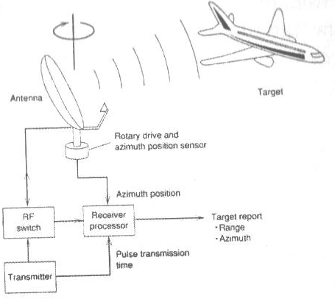
Figure 2.1: Primary Radar (PR)

- AIR TRAFFIC CONTROL & MANAGEMENT

- The three airtraffic servioces are:
  - Air Traffic Control (ATC): Maintain a safe distance between aircraft and obstacles within a confined airspace and also on the airport surface.
  - Air Space Management (ASM): maximize, within a give airspace structure, the utilization of available airspace by dynamic time sharing and, at times, segregation of airspace among a competing categories of user based on short-term needs.
  - Air Traffic Flow Management (ATFM): ensure an optimum flow of air traffic through areas during times when demands exceed (or is expected to exceed) the available capacity of the ATC service.
- They are:
  - CTR: Control Zone: local ATC (TWR), usually circular area around airport.
  - CTA: Control Area: general ATC (ACC) within FIR, below certain flight level (lower airspace).
  - UTA: Upper Control Area: general ATC, across FIRs (upper airspace, e.g. Eurocontrol).
  - TMA: Terminal Control Area: local ATC (APP), incoming and outgoing flights between CTR and CTA.
- ??
- They are:
  - STAR: Standard Terminal Arrival Route defines the route flown between an ATS route and an approach fix (connects CTA with CTR, trough TMA).
  - SID: Standard Instrument Departure defines the route flown between aircraft departure and an ATS route (connects CTR with CTA, through TMA).
  - They were established for:
    - Noise abatement;
    - Reduction of communication (voice) between pilot and controller;
    - Allowing separation of incoming and outgoing traffic.
- From UTA, into CTA, through TMA into CTR.

- LANDING GUIDANCE SYSTEMS

- The ICAO Landing Categories are:
  - CAT I: Decision Height (DH) > 200 ft, Runway Visual range (RVR) ≥ 2600 ft
  - CAT II: DH > 100ft, RVR ≥ 1200 ft.
  - CAT III: DH < 100 ft, RVR ≤ 1200 ft, CAT III is further categorized into:
    - CAT IIIa: DH < 100 ft, RVR ≥ 700 ft (see to land)
    - CAT IIIb: DH < 50 ft, RVR ≥ 150 ft (see to taxi)
    - CAT IIIc: No limits for DH and RVR (zero visibility)
- He does that in the following ways:
  - IIIa: Fail-passive (dual) autopilot or HUD;
  - IIIb: Fail-operational (triple) autopilot, automatic rollout;
  - IIIc: This category has not yet been approved.
- See figure 4.1. A Basic MLS consists of azimuth and elevation ground stations and a conventional DMW, allowing 3D positioning on approach courses to 40 degree on either side of the center line and to 15 degree above the runway.
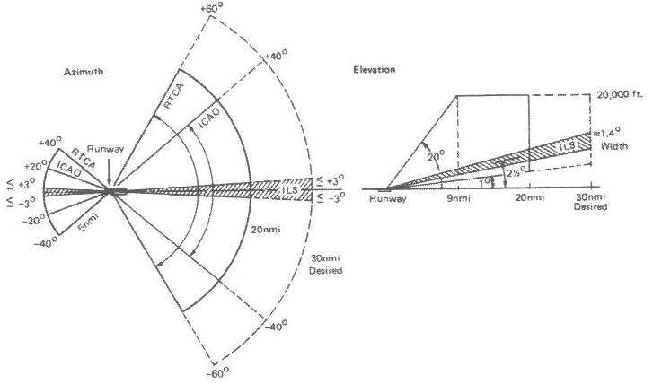
Figure 4.1: MLS
- Azimuth and elevation angels are obtained by measuring the time-difference between tow pulses (TO and FRO scan) which are received if the narrow antenna pattern if the appropriate ground station passes the aircraft twice.
- It has the following advantages:
  - Multiple approach paths;
  - Larger approach angles and range;
  - Insensitive to multipath effects;
  - Usable at any airport;
  - Larger number of channels.
- TERRESTRIAL RADIO NAVIGATION

- DME stands for Distance Measuring Equipment.
- The DME sytem works as follows:
  - DME is based on the measurement of the time interval between a pulse transmitted by the aircraft airborne DME interrogator and the reception of that pulse sent back (after a fixed time delay of 50 μs) by a ground based DME responder. The airborne equipment computes the slant range (line-of-sight distance) between the aircraft and DME station.
  - A DME channel consists of two carrier wave frequencies, always 63 MHz apart. The pulses, using a cos²-shape, are amplitude modulated on the carrier wave, in pairs 12 μs apart.
  - The interrogator can be in two modes, in the search mode the interrogator has not yet received an ‘answer’ from the ground based station and sends out 140 pulse-pairs per second. It has to recognize its own replies and ignore the replies to the DME interrogators of other aircraft. In the tracking mode the interrogator has recognized its own replies and is converting the information to a slant range. It sends about 5 to 8 pulse pars per second.
  - Typical DME accuracy is 0.25 nm =1.25%R, with R the range in nm. The ground station responds to the interrogation of 50 – 100 aircraft.
  - The interrogator has to recognize its own received replies form the received array of replies to all other aircraft using the DME station.
- For this purpose, the A/C interrogator is made to interrogate with its own rhythm (or jitter) and the looks for replies with a constant time difference with respect to the interrogator transmission.
- GDOP is the Geometric Dilution of Precision, see lecture notes + figure 5.1.
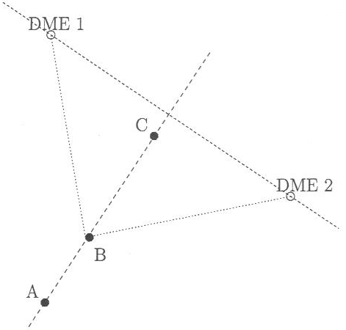
Figure 5.1: GDOP for DME
- TACAN us a military omnibearing (like VOR) and distance measurement (like DME) system. Civil aircraft can use the TACAN beacon as if it would be a DME beacon. They cannot use the omnibearing facility of TACAN. For this purpose, TACAN beacons are often augmented with a VOR transmitter, yielding the so called VORTAC station.

- INERTIAL NAVIGATION SYSTEM

- If the vehicle acceleration components can be derived along a precisely know set of axes, successive integration of the acceleration components with respect to time yield the velocities and distances travelled along these axes (if initial conditions are known).
- Accelerometers and gyroscopes. An INS can detect a change in its geographic position (a move east or north, for example), a change in its velocity (speed and direction of movement), and a change in its orientation (rotation about an axis). It does this by measuring the linear and angular accelerations applied to the system. Since it requires no external reference (after initialization), it is immune to jamming and deception.
- The main INS components the stable platform (gimbaled) IN system and Strapdown IN system, they work as follows:
- The gimbaled platform isolates the inertial sensors (accelerometers and gyroscopes) form the angular motions of the vehicle, i.e. the platform maintains a fixed orientation with respect to the Earth (F^{g}). The accelerometer measurements can be integrated directly in the navigation coordinates (in F^{g}).
- In case of Strapdown IN, the inertial sensors are mounted directly on the vehicle. Algorithms in a digital computer transform the accelerometer measurements form vehicle coordinates (in F^{b}) to the navigation coordinates (F^{g}) , after which the transformed accelerations are integrated.
With less moving parts and mechanisms than gimbaled systems, strapdown inertial navigation systems have strongly benefited from the advance of computer technologies, being built upon electronics, optics, and solid state technology. Perhaps a gimbaled INS's primary advantage is it's inherently lower error. Since it's three orthogonal accelerometers are held in a fixed inertial orientation, only the vertically oriented one will be measuring gravity (and therefore experiencing gravity-related errors).
- See figure 6.1.
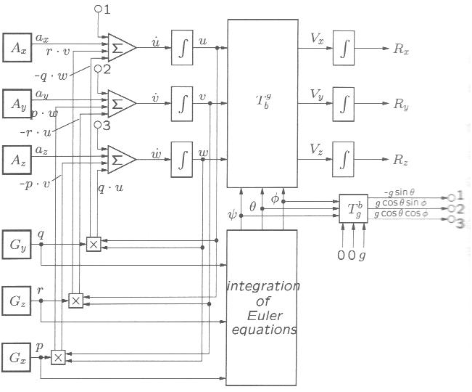
Figure 6.1: The ANALYTIC platform

