AE2-521N

Year: 2007-2008

Exercise section I

In this small report there will be an elaboration of two problems that were given in the first exercise section of structural analysis given by Mr. Abdalla. If there are some mistakes or you don’t understand the explanation, just look at the problems and solutions well and, if necessary, correct the mistakes for yourself and try to figure it out; but I do not think there will be problems. The solutions will be supported with sketches.

First thing: both problems are statically indetermined and will be solved by means of dummy-loads. All the forces are given in N and all the lengths (including in the sketches) are given in cm and crossectional areas in cm².

Forces

As already is said: the structure (figure 1) given below is statically indetermined. Why? If you look at the total joints (red spots) and members, then you look at it as follows:

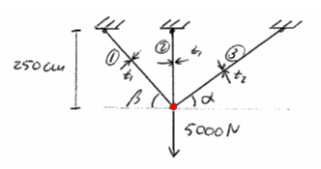

The number of joints: 1
The number of members: 3

In every joint you have two equilibrium equations: the sum of the forces in the x-direction and the sum of the forces in the y-direction. This means that the total sum of equilibrium equations then equals: (number of joints)*(number of equilibrium forces) = 1*2 = 2. But, the number of members equals 3. So you miss 3-2 = 1 equation to solve the system. That is why it is a first degree statically indetermined structure. Important: you do not count the hinges in A, B and C!

Because the system is first degree indetermined, you must assume that the force on one of the members is zero and act a dummy-load on it. See figure 2. A force of 5000N acts on the system. β = 45° and α = 30°. The crossectional area: A₁ = 0.5cm and A₂ = 1.0cm. Watch out for the units, stay constant! The assumption that has been made is: the force in member 3 = 0 and put a dummy-load (unit-load of 1, see right part of fig.2) on it. The R in the right part of the system must, at the end, get reaction force in member 3.

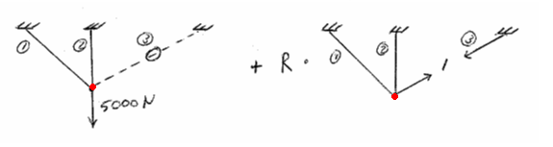
The external load is only applied once!

If you look at the left part fig.2, the force in member 1 = 0N! There was a question during the section: How can it be zero, because if you look at it geometrically you must have a force acting on it? Answer; we assume that member 1 moves without deformation; it will not elongate!

So if you continue like this, calculating on the hinge the forces in the x- and y-direction on both sides then you get the forces acting on it, which equals F_{n} _{and} f_{n}.
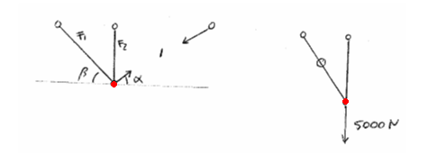

Example, on the left side:

So, what you actually do is dividing the system and make both system statically determined; so you can use: The sum of the forces = 0.

If you do this, you will get the next table:

Members | 1st system  F (N) | 2nd system  f (N) | Length  (cm) | A  (cm²) | E (aluminum)  (N/cm²)
1 | 0 | 1.225 | 353.6 | 0.5 | 200e⁵
2 | 5000 | -1.336 | 250 | 0.5 | 200e⁵
3 | 0 | 1 | 500 | 1.0 | 200e⁵

Next, the force in each member is:

Member 1: F = 0 + 1.225*R
Member 2: F = 5000 – 1.336*R
Member 3: F = 0 + R

With the next formula you can calculate the unknown R:

Recall that it is the summation of all the members. Where F = total load, f = unit load. This will give the next:

Thus:

F (N) (each member) | F (N) (real)
0 + 1.225*R | 1677
5000 – 1.336*R | 3129
0 + R | 1369

Abdalla: ‘Try to do this at home, but instead of taking member 3 as a redundant, use the left member (member 1). You should get the same answers!’

Problem I - Displacement

Next: Find the vertical displacement. Mr. Abdalla did this twice, changing the redundant.

Example 1

First, put a dummy-load in member 3, see fig. eeee. You can put the dummy-load everywhere you want to decide the displacement. This section looks a lot like the first calculation. You calculate all the forces F and f (because the direction of this dummy-load is the same as the force of 5000N, the forces stays the same. Not sure, but you could check it out). You will get the next table; watch out with the differences with the first table!

Members | F (N) (real) | f (N) | Length  (cm) | A  (cm²) | E (aluminum)  (N/cm²)
1 | 1677 | 0 | 353.6 | 0.5 | 200e⁵
2 | 3129 | 1 | 250 | 0.5 | 200e⁵
3 | 1369 | 0 | 500 | 1.0 | 200e⁵

With the next formula, you will get to the vertical displacement:

Example 2

Put a dummy-load on member 2, calculate the forces F and f. Put these values in a table like above. Fill the forces (L, E, A are idem dito the same as above). You will get the same value of 0.078cm.

Problem II – Forces

This problem will be treated exactly as the preceding problem. So, this time the explanation will not be extensive. The next example is given to show you that this method (dummy-load) can also be used for a multiple freedom of statically indeterminacy.
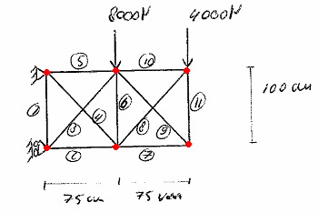

Okay, just like before, Abdalla started with the determination of the statically indeterminacy.

The number of joints: 6
The number of members: 11
The number of reaction-forces: 3 (at the supports, two in the x-direction, one in the y-direction)

Thus, the system has (6*2) = 12 equilibrium equations. The total forces are 11+3 = 14 forces. So the system is 14-12 = 2 degrees statically indetermined. So, you must remove two members, see figure:
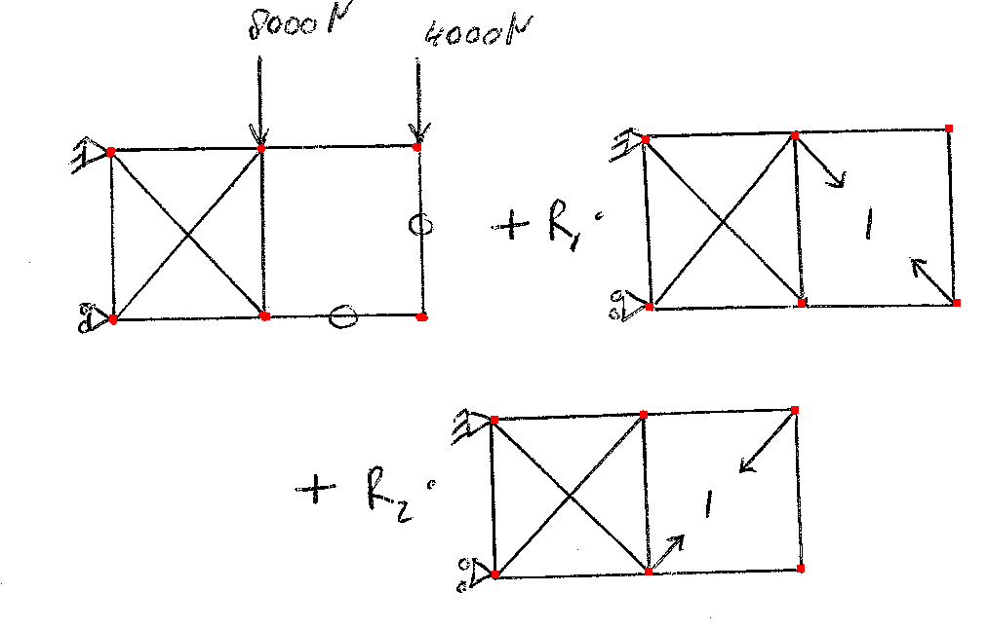
In this case (when you have a multiple indeterminacy), you are allowed to remove to members from the right part and put them somewhere else. Mr. Abdalla did the following, look well:

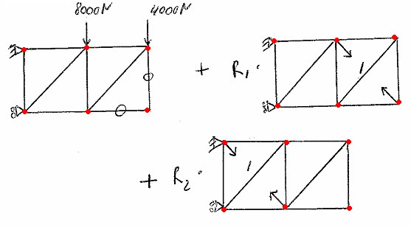

Also for this, you must calculate the forces F and f. Abdalla said, this is something that, if you understand this, you could do it in no-time (approximately 7 minutes!). If something isn’t explained, it shouldn’t be a problem. You will get the next table; A = 0.5cm² (for all members), E remain the same as above and L can simply be calculated.

Member | 1st System  F_{w} (N) | 2nd System  f₁ (N) | 3th System  f₂ (N)
1 | 12000 | 0 | -0.8
2 | -3000 | 0 | -0.6
3 | -15000 | 0 | 1
4 | 0 | 0 | 1
5 | 12000 | 0 | -0.6
6 | 4000 | -0.8 | -0.8
7 | 0 | -0.6 | -0.6
8 | -5000 | 1 | 1
9 | 0 | 1 | 1
10 | 3000 | -0.6 | -0.6
11 | 0 | -0.8 | -0.8

IMPORTANT: Reactions don’t have to be calculated!

So now we did the same thing as before, but now with:

and

f₁ is the first redundant.
f₂ is the second redundant.

In which the total force on a member will be: F = F_{w}+R₁* f₁+ R₂* f₂. But first R (1) and R (2) must be calculated and this can be done with the following formulas (the answers are immediately calculated). Remember that the summation is of all the members in the system!!!

This will give the values R (1) = 1450N and R (2) = 7088.4N. And so you can do the same thing like the first problem. With the displacement you could do idem ditto the same thing.

