**Course: Aircraft Design and Operation AE4-211**

**Date: 22-01-2010**

**--------------------------------------------------------------------------------------------------------------------------------------**

1. Aerodynamic design means finding a shape that will give a desired pressure distribution in a parallel flow (blz:33).
2. The two main requirements to be imposed upon a desired pressure distribution:

* If no resultant forces are required: Minimize local supervelocities.
* If resultant forces are required: Optimize pressure distribution at the relevant flight conditions such that minimum momentum loss in the boundary layer and behind the shockwave occurs.

1. Third requirement to be imposed on the geometry as a consequence of the actual pressure distribution:

* On components which must tolerate a large variation in local flow direction: find leading edge shapes and design pressure distributions which allow for this variation.

1. Airfoils
2. What are the differences between a modern supercritical airfoil and so-called "sonic rooftop" profile in an aerodynamic sense? Refer in your answer to the critical pressure coefficient.

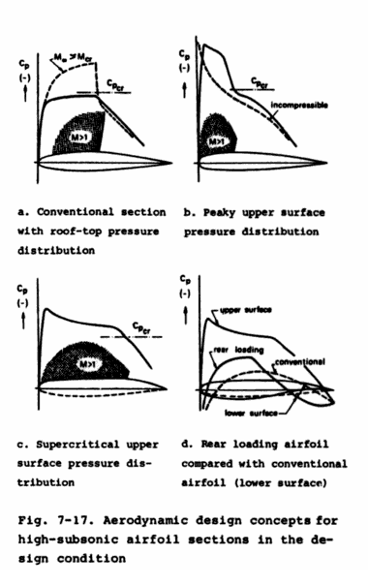

To have an as high as possible lift coefficient, yet no supersonic flow, the sonic roof-top airfoil was designed. Roof-top pressure distribution have a gradually changing or approximately constant upper surface pressure over the forward part of the section, which delays the critical Mach number by virtue of a uniform velocity at the design condition.

Slightly above this speed large regions of supersonic flow will appear and the associated suction forces then occur near the highest point of the airfoil relative to the free flow direction of the airfoil or behind it.

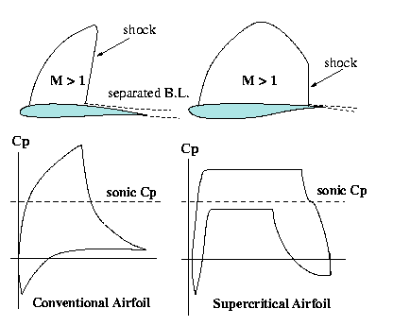The supercritical airfoil has supersonic flow over the airfoil when flying at a high enough Mach number. At a certain point along the airfoil, a shock is generated, which increases the [pressure coefficient](http://en.wikipedia.org/wiki/Pressure_coefficient) to the critical value Cp-crit, where the local flow velocity will be Mach 1. The position of this shockwave is determined by the geometry of the airfoil. A supercritical foil is more efficient because the shockwave is minimized and is created as far aft as possible thus reducing [drag](http://en.wikipedia.org/wiki/Drag_(physics)). Compared to a typical airfoil section, the supercritical airfoil creates more of its lift at the aft end, due to its more even pressure distribution over the upper surface.

1. Sketch of the differences:

H16 blz. 85 reader

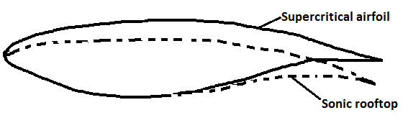

1. Airbus A380
2. General principle of a swept wing:

The airflow only experiences curvature in the direction of the incoming flow. The only velocity vector that determines the pressure distribution over the airfoil is the component Ve perpendicular to the leading and trailing edges. The velocity component parallel to the wing does not contribute to the pressure distribution or lift.

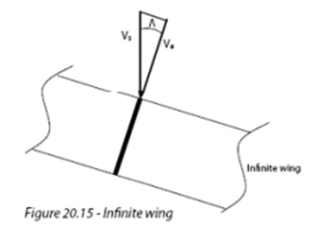

1. Explain what is meant by the "tip effect" of a swept wing.

The isobars bend to the front at the tip causing a rise in drag.

1. Why is the "tip effect" undesirable during cruise flight?

At the tip the drag coefficient is negative because of the high pulling force there. This force may even overcome the skin friction drag resulting in a pulling force on the wing. The profile drag increases because of the reduction of nose suction and the wave drag increases.

1. How can the "tip effect" be remedied?

By bending back the isobars and as a consequence reduce wave drag. This can be done by:

* extension of the tip of the wing, Küchemann tip.
* nose thinner and the trailing edge thicker, reduce thickness in direction of tip

1. Explain what is meant by the "root effect" of a swept wing.

The isobars bend back at the root.

1. Why is the root effect undesired during cruise flight?

At the inboard side, the root, drag is increasing because of the lack of suction. The profile drag increases because of reduction of nose suction and wave drag increases.

1. Give four measures that can be taken to reduce the "root effect".

* thickening root, thicker leading edge and thinner trailing edge
* An overall increase in thickness.
* reduce camber of the airfoil at root
* reduce thickness in direction tip
* Increase the incidence of the wing
* Increase the lower surface contour
* less sweep at tip than at root
* evenly distributed pressure distribution

**all are meant to straighten the isobars**

1. Based on your knowledge of root and tip effects, explain the increased sweep of the inboard wing of the A380.

The increased sweep of the inboard wing is to keep the isobars from unsweeping. Increasing the sweep at the inboard wing causes the isobars to bend forward which straightens them. Outboard wing stalls sooner than inboard wing due to crossflow.

1. Dorsal fin
2. What is the function of a Dorsal fin?

A dorsal fin increases the stall angle because of a larger leading edge vortex. This vortex postpones flow separation and therefore a greater stall angle and maximum lift coefficient can be achieved. Up to 15o side-slip angle no use, above 15o vortex over vertical tail is created. Flow separation with higher β(side-slip angle).

1. Why can the A320 do without a Dorsal fin?

A320 has a swept tail which has the same effect as a dorsal fin. Fokker 50 does not have a swept tail, it has a straight tail. Therefore it needs the dorsal fin.

1. -
2. Cessna Citation
3. What are the three types of stall?

* ***Trailing edge stall***

Boundary layer separation starts at the trailing edge and gradually spreads forward. Occurs on sections with large leading edge radii and strong upper surface curvature.

* ***Leading edge stall***

Abrupt, causes flow separation over almost the entire section. Small bubble at front that 'bursts'. Occurs at thin airfoil profiles and sections with moderate leading edge radii and upper surface distributions, at high Reynolds number. Steep gradient behind suction peak.

* ***Thin airfoil stall***

Occurs on airfoils with small leading edge radii or at sections with a thicker leading edge at low Reynolds numbers. Flow goes turbulent/separates and reattaches after which it goes again turbulent and separates -> stall

Happens in a windtunnel

1. Which type do you expect for this particular aircraft type? Why?

Leading edge stall, the aircraft flies at high Reynolds number and has a thin profile. A high suction peak behind the leading edge originates causing the aircraft to stall abruptly.

1. What is the explanation for the difference between 99 KIAS and 110 KIAS?

In the 60s the way to determine the stall speed was different from today. Back then the minimum stall speed was determined at 1g. Stall speed today is determined by doing maneuvers, at maneuver other conditions, not 1g. Due to a higher Reynolds number the curve has shifted upwards causing a higher stall speed.

1. Deflected plates
2. What is their proper name and what are they for? Explain their function carefully in relation to the wing itself.

***Krueger flaps***

High lift device. The aerodynamic effect of Krueger flaps is similar to that of [slats](http://en.wikipedia.org/wiki/Leading_edge_slats) or [slots](http://en.wikipedia.org/wiki/Leading_edge_slot), however they are deployed differently. Krueger flaps, hinged at their leading edges, extend forwards from the under surface of the wing, increasing the effective chord and therefore the maximum lift coefficient. Conversely, slats extend outwards from the leading edge.

A slot allows the velocity to change between the upper and lower surface. With a slot the mutual beneficial interference effect is increased. A new boundary layer can be formed on a new element. This new boundary layer can withstand higher pressure gradients than the exhausted one from the wing.

1. Why do they not extend to the fuselage?

Because a new boundary layer is formed, which is fresh, the flow does not separate at high angles of attack.

This Boeing has a normal straight wing, but nowadays we have negative camber etc. Therefore the inboard wing does stall and the flaps reach until the fuselage.

1. -
2. Thrust reverser Boeing 737-200.
3. What type of thrust reversers are these?

Bucket or target type thrust reverser

1. How do they function?

They redirect the airflow such that the thrust goes down and they are used as a brake. Their main effect lies in decreasing the ground roll distance on wet and icy or snow covered runways and providing an extra element of safety. They are not allowed to reduce the certified landing distance.

1. Name two specific advantages for this type of thrust reverser.

* Better performance due to generating more drag, ground roll distance is reduced further than with cascade type thrust reversers.
* They are lighter, less complex and require less maintenance than cascade thrust reversers.

1. Name two specific disadvantages for this type of thrust reverser.

* Target type thrust reversers have much less control over the direction of the exhaust flow than cascade type thrust reversers. In particular rear-fuselage mounted engines may cause problems both with rudder control and with nose wheel steering because of reduced nose-wheel loads.
* Reverser efficiency of a target thrust reverser is lower than of a cascade fan.

1. Buffet-onset boundary
2. Explain the physical cause for transonic buffet.

Buffeting is the phenomenon that makes the aircraft vibrate because the boundary layer separates at the foot of the shockwave. This speparation occurs as a separation bubble which gradually increases towards the trailing edge with increasing angle-of-attack or Mach number. In case α is increased, more lift is produced, but it also results in stronger buffeting. This is true in particular for wings with high aspect ratio's.

1. Using simple sweep theory, explain why an increase in wing sweep lowers the maximum lift coefficient.

The airflow only experiences curvature in the direction of the incoming flow. The only velocity vector that determines the pressure distribution over the airfoil is the component Ve perpendicular to the leading and trailing edges. The velocity component parallel to the wing does not contribute to the pressure distribution or lift. Increasing the sweep angle increases the velocity component Vpar and decreases the velocity component Ve. The speed of the air relative to the leading edge of the wing is thus reduced. Since Ve contributes to the pressure distribution and therefore the lift, the lift will decrease if Ve decreases. Since the maximum lift is reduced the maximum lift coefficient will be reduced as well.

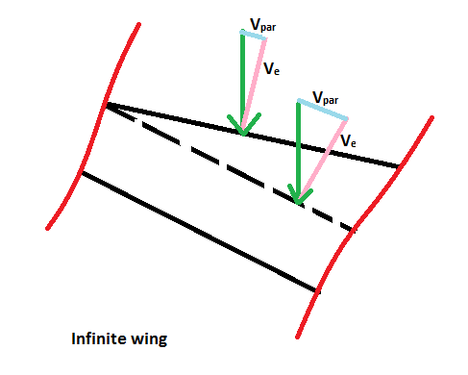

1. Based on your knowledge of the pressure distribution over a supercritical airfoil, explain why an increase in thickness leads to a decrease in buffet-onset Mach number.

When adding thickness to an airfoil with constant camber, higher speeds will occur at the thicker location, which means that the same lift coefficient can be achieved at a lower Mach number. Therefore when having a supercritical airfoil, the shock wave position at which flow separation (buffet) occurs moves forward. The buffet-onset Mach number decreases.

1. DC-10 versus MD-11
2. Explain the aerodynamic cause for drag divergence.

-

1. Explain the aerodynamic cause for drag creep.

-

1. Explain how the addition of aft loading on the MD-11 (the DC-10 did not have any) resulted in less drag creep for the same lift coefficient.

-

1. The Ilyushin Il-62 features a large cone protruding ahead of the intersection of the vertical and horizontal stabilizer. Give an aerodynamic explanation for its presence.

The intersection of the horizontal and vertical tail causes a sum of the supervelocities which is unfavorable. The supervelocities of the horizontal and vertical tail are added. To counteract this effect a fairing is used. This way the boundary layers of the horizontal and vertical tail are separated. This reduces the interference and wave drag.

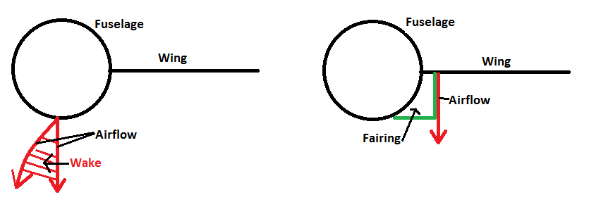

1. Transport aircraft
2. What is the maximum angle of attack this aircraft can attain at the point of lift-off?

-

1. What is the maximum angle of attack this aircraft can attain close to touch down?

-

1. For each of the three take-off flap positions, calculate the lift-off velocity, expressed as a fraction of the stall speed, Vs.

-

1. For the landing configuration, calculate the minimum touch-down velocity, expressed as a fraction of the stall speed, Vs.

-

1. Does it make sense to deploy the slats during take-off? Why?

-

1. Does it make sense to deploy the slats during landing? Why?

Yes, since when slats are deployed, they allow the wing to operate at a higher angle of attack. During landing an angle of attack of .. is needed.

blz.219

409