**Course: Aircraft Design and Operation AE4-211**

**Date: 15-01-2007**

**--------------------------------------------------------------------------------------------------------------------------------------**

1. Wing sweep
2. General principle of a swept wing:

The airflow only experiences curvature in the direction of the incoming flow. The only velocity vector that determines the pressure distribution over the airfoil is the component Ve perpendicular to the leading and trailing edges. The velocity component parallel to the wing does not contribute to the pressure distribution or lift.

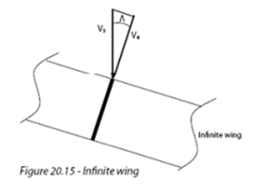

1. Specific problems associated with finite swept wings:

* Effective lift coefficient decreases if a wing is swept
* High speed aircraft with high swept wings produce less lift -> difficulties with take-off and landing. These aircraft require high lift devices in order to be able to take-off and land.

1. The increased sweep of the inboard wing is to keep the isobars from unsweeping. Outboard wing stalls sooner than inboard wing due to crossflow.
2. H11 reader

Bulb causes negative Cp -> positive pressure. It acts like a fence.

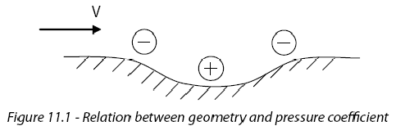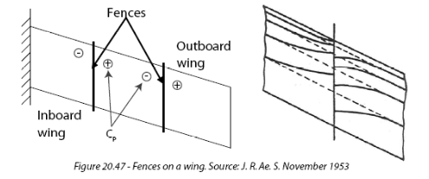

Supervelocities do not only occur due to the presence of one component, but may even be higher at intersections of two or more aircraft components. The unfavorable summation of these supervelocities causes interference drag. In the design process shapes should therefore be pursued such that a proper interposition of the various components leads to a favorable summation of supervelocities. This means that if one component has a negative pressure coefficient, the intersecting component should at that location have a low negative or even positive Cp. This can be done by local shape modifications like the bulb on the side of the pylon since wing-nacelle combinations regularly raises problems in terms of interference drag. To reduce drag, the bulb on the side of the pylon was necessary.

1. A340 wing fuselage fairing

When wing and fuselage are considered together, supervelocities of the individual components are added. The lift over the wing is increased due to the presence of the fuselage. Adding the superveocities of fuselage to those of the wing alters the variation of the local lift coefficient over the wing span.

Due to the fairing the downwash does not have to bend around the fuselage. Less interference drag. The boundary layers of the fuselage and wing are separated which reduces the risk of shockwaves and wave drag.

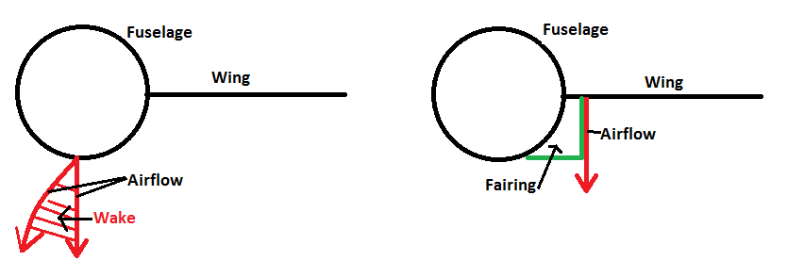

1. Dorsal fin

A dorsal fin increases the stall angle because of a larger leading edge vortex. This vortex postpones flow separation and therefore a greater stall angle and maximum lift coefficient can be achieved. Up to 15o side-slip angle no use, above 15o vortex over vertical tail is created. Flow separation with higher β(side-slip angle).

1. Upper part of the rudder has been lengthened to the front.
2. What purpose does this serve and how exactly does it operate? Clarify your answer with pressure distributions.

Mach trim compensator. Aerodynamic balancing to reduce forces

1. What does this teach you about the type of directional control system?

Manual control system

1. B707 deflected plates:
2. What is their proper name and what are they for? Explain their function carefully in relation to the wing itself.

***Krueger flap***

Works the same as a slat, only deploys differently. A Krueger flap extends forward from under the surface of the wing increasing the wing camber and maximum lift coefficient. They increase the angle of attack which results in a higher stall angle.

1. Why are they not extended right up to the fuselage?

Difficult to make due to double curvature.

Higher stall angles can be achieved at the inboard wing than at the outboard wing. Therefore they are not needed at the root, the outboard wing stalls first.

1. H16 blz:85 Reader

State of the art profile: Supercritical airfoil

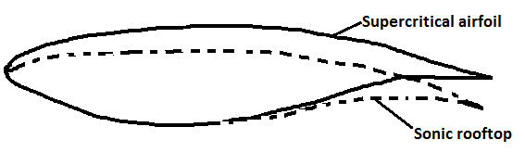

The pressure distributions for the low-subsonic and transonic region can be found on page 244 of the book.

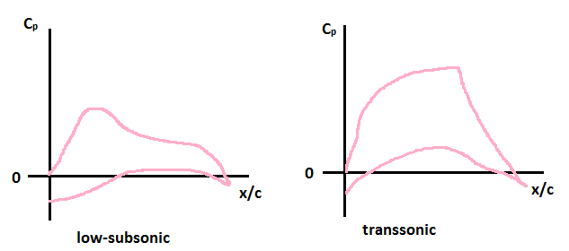

1. Transsonic bussiness jet Cessna X
2. Where do you expect in general the stalled area of the wing? Why?

First at the outboard wing, at the outboard wing the boundary layer is thicker and piles up.



1. Where about do you expect the weak shockwave on the wing during cruise or at higher Mach numbers?

Because the isobars are bent back at the root at high M and α, the pressure distribution differs a lot from the simple sweep theory. Therefore high velocities occur at the back of the root which lead to shock waves and separation.

1. What do you learn from that concerning the intention of the vortex generators?

The vortex generators try to bend back the isobars (straighten them) which reduces the induced drag. Less cross flow.

1. Explain their operation. Why have they been inclined under an angle?

nvt (not requested)

1. The lower rear surface of the wing of the Airbus A340 exhibits a strong camber.
2. What are its specific advantages and disadvantages?

Advantage: Stronger aft wing loading -> more lift

Disadvantage: larger moment, larger negative zero-pitching moment (blz.94 book)

1. This curvature almost disappears in the region of the root. Explain this using the general wing design goals.

Improving velocity distribution. At the outside you want more lift -> more camber needed -> stronger negative pitching coefficient. To compensate for this, at root as much lift as possible through front loading. As little as possible aft loading at root -> less camber.

This also gives more room for flaps and undercarriage because the leading edge is thicker.

1. Tuck under

When accelerating at an already high Mach number, a phenomenon called "tuck-under" may appear. Due to this acceleration, the pressure distribution will have a longer area of highly negative Cp-values. This pushes the aerodynamic center to the trailing edge of the wing, due to the increased rear loading. The neutral point will move towards the leading edge because of the higher lift at the wing and the nearly non-changing lift of the tail surfaces. But, at some even higher Mach number, the larger region of negative Cp-values will end because the flow will start to separate at the foot of the shockwave. This is the effect of buffeting. Because of the flow separation, some of the lift will be lost and the aerodynamic center will move forward again. Since the tail surfaces are designed to not have flow separation, the neutral point will move to the rear again. (blz.261 reader)

Thus, when accelerating to such high Mach numbers that the flow separates over the main wing, the aerodynamic center will move to the front and the neutral point will move to the back. This increasing distance between the aerodynamic center and the neutral point results in an increasing negative pitching moment, meaning the nose will pitch down and the aircraft will dive, picking up even more speed.

**All moving tail to cure tuck under.**



1. Fokker Friendship F-27

-

1. To your surprise it is discovered later that the actual drag as determined from flight tests is lower still than your windtunnel measurements. What is the proper explanation for this?

Untill a certain Reynoldsnumber drag decreases with increasing Reynolds number. But, counter intuitively above a given critical Relynolds number drag remains constant for a given grain size (blz.363 reader).

In reality, the implicit assumptions that were made are not correct(blz.524).

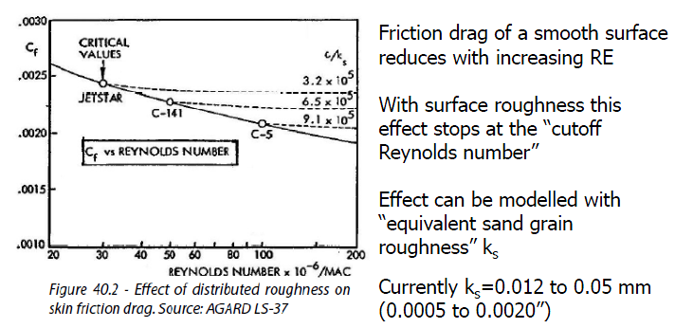

1. Cessna Citation
2. What are the three types of stall?

* ***Trailing edge stall***

Boundary layer separation starts at the trailing edge and gradually spreads forward. Occurs on sections with large leading edge radii and strong upper surface curvature.

* ***Leading edge stall***

Abrupt, causes flow separation over almost the entire section. Small bubble at front that 'bursts'. Occurs at thin airfoil profiles and sections with moderate leading edge radii and upper surface distributions, at high Reynolds number. Steep gradient behind suction peak.

* ***Thin airfoil stall***

Occurs on airfoils with small leading edge radii or at sections with a thicker leading edge at low Reynolds numbers. Flow goes turbulent/separates and reattaches after which it goes again turbulent and separates -> stall

Happens in a windtunnel

1. Which type do you expect for this particular aircraft type? Why?

Leading edge stall, the aircraft flies at high Reynolds number and has a thin profile. A high suction peak behind the leading edge originates causing the aircraft to stall abruptly.

1. What is the explanation for the difference between 99 KIAS and 110 KIAS?

In the 60s the way to determine the stall speed was different from today. Back then the minimum stall speed was determined at 1g. Stall speed today is determined by doing maneuvers, at maneuver other conditions, not 1g. Due to a higher Reynolds number the curve has shifted upwards causing a higher stall speed.

1. Calculated pressure distribution B-52 bomber for two cases, rigid jigshape and deformations under aerodynamic loads.
2. Explain the differences in the pressure distributions

The flexible wing bends upwards at the tip which increases the angle and less lift is produced. Because the wing bends, an angle of twist is created which reduces the effective angle of attack α. The rear spar bends upwards further than the front spar causing a progressive decrease in angle of attack towards the wing tip.

The suction peak of the rigid design is larger which is better, more lift and higher maximum lift coefficient.

1. Which of both situations is beneficial for the Mach-dependant drag: the rigid or flexible one? Why?

Induced drag, eliptical lift distribution -> higher maximum lift coefficient at the tip. Therefore the rigid design is better. Suction peak rigid design is larger -> more lift is being produced -> higher maximum lift coefficient.