**Course: Aircraft Design and Operation AE4-211**

**Date: 17-01-2005**

**--------------------------------------------------------------------------------------------------------------------------------------**

1. Aerodynamic design means finding a shape that will give a desired pressure distribution in a parallel flow (blz:33).
2. The two main requirements to be imposed upon a desired pressure distribution:

* If no resultant forces are required: Minimize local supervelocities.
* If resultant forces are required: Optimize pressure distribution at the relevant flight conditions such that minimum momentum loss in the boundary layer and behind the shockwave occurs.

1. Third requirement to be imposed on the geometry as a consequence of the actual pressure distribution:

* On components which must tolerate a large variation in local flow direction: find leading edge shapes and design pressure distributions which allow for this variation.

1. blz: 77 book
2. When wing and fuselage are considered together, supervelocities of the individual components are added. The lift over the wing is increased due to the presence of the fuselage. Adding the superveocities of fuselage to those of the wing alters the variation of the local lift coefficient over the wing span.

Due to the fairing the downwash does not have to bend around the fuselage. Less interference drag. The boundary layers of the fuselage and wing are separated which reduces the risk of shockwaves and wave drag.

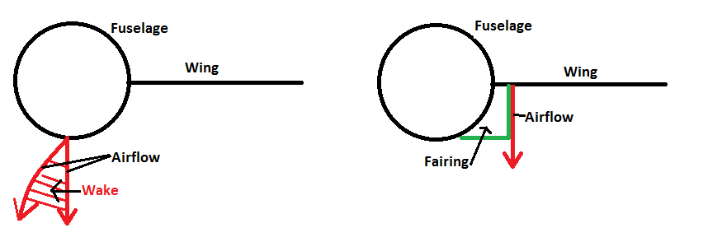

1. Shark fin vertical tail:
2. Tails with a dorsal fin can achieve higher stall angles because of a larger leading edge vortex. This vortex postpones flow separation and therefore a greater stall angle and maximum lift coefficient can be achieved.

Furthermore, the tail fin is swept back. This is done to give a better performance at increased angle of attack and side-slip angle. A higher sweep angle gives a higher lift coefficient at a higher side-slip angle.

drawbacks: hard to produce

1. One could say it is better for area ruling, but since it are such small volumes this is not important. Therefore it has no aerodynamic significance.
2. B707 deflected plates:
3. What is their proper name and what are they for? Explain their function carefully in relation to the wing itself.

***Krueger flap***

Works the same as a slat, only deploys differently. A Krueger flap extends forward from under the surface of the wing increasing the wing camber and maximum lift coefficient. They increase the angle of attack which results in a higher stall angle.

1. Why are they not extended right up to the fuselage?

Difficult to make due to double curvature.

Higher stall angles can be achieved at the inboard wing than at the outboard wing. Therefore they are not needed at the root, the outboard wing stalls first.

1. H16 blz:85 Reader

State of the art profile: Supercritical airfoil

The pressure distributions for the low-subsonic and transonic region can be found on page 244 of the book.

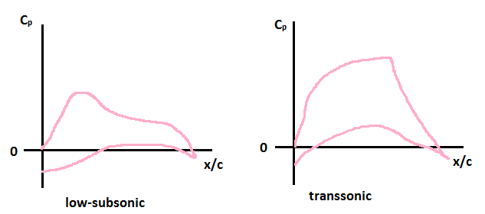

1. Transsonic bussiness jet Cessna X
2. Where do you expect in general the stalled area of the wing? Why?

First at the outboard wing, at the outboard wing the boundary layer is thicker and piles up.

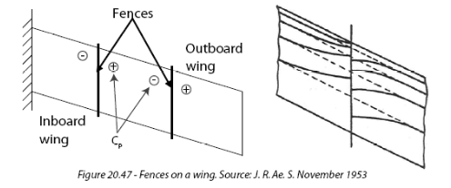

1. Where about do you expect the weak shockwave on the wing during cruise or at higher Mach numbers?

Because the isobars are bent back at the root at high M and α, the pressure distribution differs a lot from the simple sweep theory. Therefore high velocities occur at the back of the root which lead to shock waves and separation.

1. What do you learn from that concerning the intention of the vortex generators?

The vortex generators try to bend back the isobars (straighten them) which reduces the induced drag. Less cross flow.

1. Explain their operation. Why have they been inclined under an angle?

nvt (not requested)

1. At the root a high incidence root airfoil is present. To straighten the isobars and counter the root effects. To the tip the incidence angle is increased so the profiles are twisted and the result is a bend down trailing edge. With this aircraft a lot of attention is paid to straighten the isobars. Therefore also the trailing edge of the wing is still swept and not straight. Part of the landing gear is in the fuselage to be able to keep sweep. More sweet front -> isobars to front. Less drag during cruise.
2. Because a test chamber for a running engine with the combination of a high Mach number and high altitude does not exist today. It has to be tested at altitude to determine the efficiency of the engine and the trust it can deliver.
3. Fokker Friendship F-27

-

1. Growth factor
2. Assume: fuel weight/take-off weight = constant

growth factor = take-off weight/ empty weight

1. -
2. They are the same since the assumption was made that the fuel weight divided by the take-off weight is constant.
3. Cessna citation
4. Various types of stall:

* Trailing edge stall

Boundary layer separation starts at the trailing edge and gradually spreads forward. Occurs on sections with large leading edge radii and strong upper surface curvature.

* Leading edge stall

Abrupt, causes flow separation over almost the entire section. Small bubble at front that 'bursts'. Occurs at thin airfoil profiles and sections with moderate leading edge radii and upper surface distributions, at high Reynolds number. Steep gradient behind suction peak.

* Thin airfoil stall

Occurs on airfoils with small leading edge radii or at sections with a thicker leading edge at low Reynolds numbers. Flow goes turbulent/separates and reattaches after which it goes again turbulent and separates -> stall

Happens in a windtunnel

1. Leading edge stall. This is a thin profile, abrupt stall. High Reynolds number -> steep pressure gradient behind suction peak. Flow does not reattach.
2. In the 60s the way to determine the stall speed was different from today. Back then the minimum stall speed was determined at 1g. Stall speed today is determined by doing maneuvers, at maneuver other conditions, not 1g. Due to a higher Reynolds number the curve has shifted upwards causing a higher stall speed.
3. Calculated pressure distribution B-52 bomber for two cases, rigid jigshape and deformations under aerodynamic loads.
4. Explain the differences in the pressure distributions

The flexible wing bends upwards at the tip which increases the angle and less lift is produced. Because the wing bends, an angle of twist is created which reduces the effective angle of attack α. The rear spar bends upwards further than the front spar causing a progressive decrease in angle of attack towards the wing tip.

The suction peak of the rigid design is larger which is better, more lift and higher maximum lift coefficient.

1. Which of both situations is beneficial for the Mach-dependant drag: the rigid or flexible one? Why?

Induced drag, eliptical lift distribution -> higher maximum lift coefficient at the tip. Therefore the rigid design is better. Suction peak rigid design is larger -> more lift is being produced -> higher maximum lift coefficient.

1. -