**Course: Aircraft Design and Operation AE4-211**

**Date: 26-03-2004**

**--------------------------------------------------------------------------------------------------------------------------------------**

1. Two symmetrical profiles. one has a realative thickness of 6%, the other of 18%. Sketch for both profiles the pressure distribution for α=0 and 6o.

blz. 77 book

1. Swept wings
2. Explain the general principle of a swept wing

***General principle of a swept wing:***

The airflow only experiences curvature in the direction of the incoming flow. The only velocity vector that determines the pressure distribution over the airfoil is the component Ve perpendicular to the leading and trailing edges. The velocity component parallel to the wing does not contribute to the pressure distribution or lift.

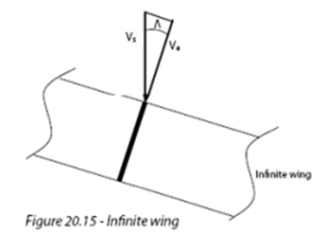

1. Elaborate specific problems associated with finite swept wings.

***Specific problems associated with finite swept wings:***

* Effective lift coefficient decreases if a wing is swept
* High speed aircraft with high swept wings produce less lift -> difficulties with take-off and landing. These aircraft require high lift devices in order to be able to take-off and land.

1. A340: Explain the presence and function of this cuff plate (hint: think of the pylon as a vertical plate acting like a mirror, just like the fuselage).

-

1. A340 wing fuselage fairing

When wing and fuselage are considered together, supervelocities of the individual components are added. The lift over the wing is increased due to the presence of the fuselage. Adding the superveocities of fuselage to those of the wing alters the variation of the local lift coefficient over the wing span.

Due to the fairing the downwash does not have to bend around the fuselage. Less interference drag. The boundary layers of the fuselage and wing are separated which reduces the risk of shockwaves and wave drag.

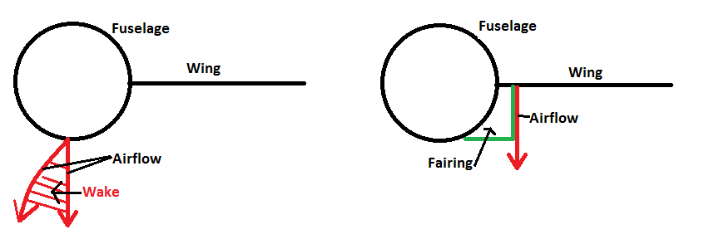

1. Large flat plate in front of the vertical stabilizer, without a distinct profile. What is its proper name and function?

***Dorsal fin***

A dorsal fin increases the stall angle because of a larger leading edge vortex. This vortex postpones flow separation and therefore a greater stall angle and maximum lift coefficient can be achieved. Up to 15o side-slip angle no use, above 15o vortex over vertical tail is created. Flow separation with higher β(side-slip angle).

1. Upper part of the rudder has been lengthened to the front.
2. What purpose does this serve and how exactly does it operate? Clarify your answer with pressure distributions.

Mach trim compensator. Aerodynamic balancing to reduce forces.

1. What does this teach you about the type of directional control system?

Manual control system

1. B707 deflected plates:
2. What is their proper name and what are they for? Explain their function carefully in relation to the wing itself.

***Krueger flap***

Works the same as a slat, only deploys differently. A Krueger flap extends forward from under the surface of the wing increasing the wing camber and maximum lift coefficient. They increase the angle of attack which results in a higher stall angle.

1. Why are they not extended right up to the fuselage?

Difficult to make due to double curvature.

Higher stall angles can be achieved at the inboard wing than at the outboard wing. Therefore they are not needed at the root, the outboard wing stalls first.

1. Initially Boeing wanted to apply the engines of the B777(MMO 0.84) on the Sonic Cruiser (M0.95-0.98) in order to save time and cost. For the same reason it would be attractive to also use the same engine nacelles including intakes. Do you consider this feasible, from an aerodynamic point of view? State your arguments clearly.

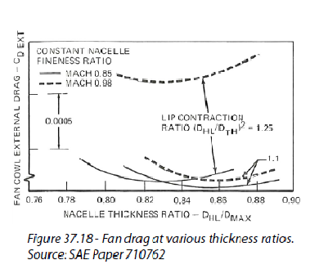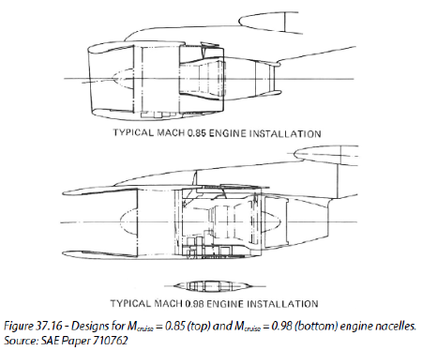Engines designed for Mach 0.98 have very thin intake lips in order to prevent bow shocks forming there. Engines designed for Mach 0.8-085 have much blunter and shorter lips. The contraction ratio corresponds to the lip shape. Lower contraction ratios result in dramatically lower efficiencies, especially if a contraction ratio of 1.1 is chosen. A contraction ratio of 1.25 results in good performance for Mach 0.85. However, at M=0.98 it results in a 5 drag counts increase in fan drag, which is unacceptable. At that speed, a contraction ratio of 1.1 gives the best result. (blz.332)

1. Transsonic bussiness jet Cessna X
2. Where do you expect in general the stalled area of the wing? Why?

First at the outboard wing, at the outboard wing the boundary layer is thicker and piles up.

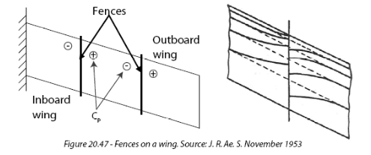

1. Where about do you expect the weak shockwave on the wing during cruise or at higher Mach numbers?

Because the isobars are bent back at the root at high M and α, the pressure distribution differs a lot from the simple sweep theory. Therefore high velocities occur at the back of the root which lead to shock waves and separation.

1. What do you learn from that concerning the intention of the vortex generators?

The vortex generators try to bend back the isobars (straighten them) which reduces the induced drag. Less cross flow.

1. Explain their operation. Why have they been inclined under an angle?

nvt (not requested)

1. The lower rear surface of the wing of the Airbus A340 exhibits a strong camber.
2. What are its specific advantages and disadvantages?

Advantage: Stronger aft wing loading -> more lift

Disadvantage: larger moment, larger negative zero-pitching moment (blz.94 book)

1. This curvature almost disappears in the region of the root. Explain this using the general wing design goals.

Improving velocity distribution. At the outside you want more lift -> more camber needed -> stronger negative pitching coefficient. To compensate for this, at root as much lift as possible through front loading. As little as possible aft loading at root -> less camber.

This also gives more room for flaps and undercarriage because the leading edge is thicker.

1. The North American P-51 Mustang distinguished itself during WWII amongst other through a different radiator position, i.e. in the fuselage directly behind the cockpit with its intake under the wing-center section. It was claimed this resulted in lower drag. Eventually some modifications were tested and applied during the development and operational use of the aircraft. This was triggered by rumbling during flight. Finally the gap between the intake lip and the fuselage lower skin was increased from 1 to 2 inches.
2. Explain how the drag of a radiator can be minimized in general.

By streamlining the flow, no sharp angles but nice fluent ones, on the inside as well as the outside. This can also be seen from Figure 9 on the exam sheet. Furthermore, the intake of the radiator should be parallel to the flow, as can be seen from the bottom figure of figure 9b. At the other configurations the intakes are not parallel to the flow.

1. Explain then why this radiator position is more beneficial than the traditional location in the nose, directly behind the propeller (Typhoon) or half embedded in the lower wing surface (Spitfire).

-

1. What was the cause of the rumbling and why did the increased gap help to cure it?

-

1. Fokker F-27 Friendship

-

1. Cessna Citation
2. What are the three types of stall?

* ***Trailing edge stall***

Boundary layer separation starts at the trailing edge and gradually spreads forward. Occurs on sections with large leading edge radii and strong upper surface curvature.

* ***Leading edge stall***

Abrupt, causes flow separation over almost the entire section. Small bubble at front that 'bursts'. Occurs at thin airfoil profiles and sections with moderate leading edge radii and upper surface distributions, at high Reynolds number. Steep gradient behind suction peak.

* ***Thin airfoil stall***

Occurs on airfoils with small leading edge radii or at sections with a thicker leading edge at low Reynolds numbers. Flow goes turbulent/separates and reattaches after which it goes again turbulent and separates -> stall

Happens in a windtunnel

1. Which type do you expect for this particular aircraft type? Why?

Leading edge stall, the aircraft flies at high Reynolds number and has a thin profile. A high suction peak behind the leading edge originates causing the aircraft to stall abruptly.

1. What is the explanation for the difference between 99 KIAS and 110 KIAS?

In the 60s the way to determine the stall speed was different from today. Back then the minimum stall speed was determined at 1g. Stall speed today is determined by doing maneuvers, at maneuver other conditions, not 1g. Due to a higher Reynolds number the curve has shifted upwards causing a higher stall speed.

1. Calculated pressure distribution B-52 bomber for two cases, rigid jigshape and deformations under aerodynamic loads.
2. Explain the differences in the pressure distributions

The flexible wing bends upwards at the tip which increases the angle and less lift is produced. Because the wing bends, an angle of twist is created which reduces the effective angle of attack α. The rear spar bends upwards further than the front spar causing a progressive decrease in angle of attack towards the wing tip.

The suction peak of the rigid design is larger which is better, more lift and higher maximum lift coefficient.

1. Which of both situations is beneficial for the Mach-dependant drag: the rigid or flexible one? Why?

Induced drag, eliptical lift distribution -> higher maximum lift coefficient at the tip. Therefore the rigid design is better. Suction peak rigid design is larger -> more lift is being produced -> higher maximum lift coefficient.

1. Boeing is studying the Sonic Cruiser, a transport airplane for 250 passengers, aimed for cruising at Mach 0.95-0.98.
2. If this cruise Mach number is interpreted as a maximum operating Mach number MMO, what does this imply for the dive Mach number MD? How do you arrive at this value?

From time to time system failures or severe atmospheric upsets cause the aircraft to pitch down and to exceed MMO in a dive. Therefore the design Mach number is equal to:

MD=MMO +0.05 to 0.09

Therefore the dive Mach number will be 1-1.17.

(design mach number: Mdesign= MMO - 0.03 to 0.05)

1. What airworthiness requirements and design goals are different in the speed regime between MMO and MD compared to speeds below MMO?

Below MMO stick reversal is not allowed, between MMO and MD it is allowed. To prevent stick reversal below MMO if it occurs, a Mach trim compensator can be used to satisfy pitch characteristics.

1. Explain from that why the aircraft is not being designed as a supersonic aircraft (as you may derive from the small sweep of the outer wing).

Because it is designed for a cruise Mach number of 0.95-0.98. Therefore also the wing sweep is small, this way the wing does produce enough lift for all flight stages. More sweep would lead to less lift and smaller lift coefficient. As a consequence such an aircraft would require very complex and highly effective high lift devices which are expensive and heavy.